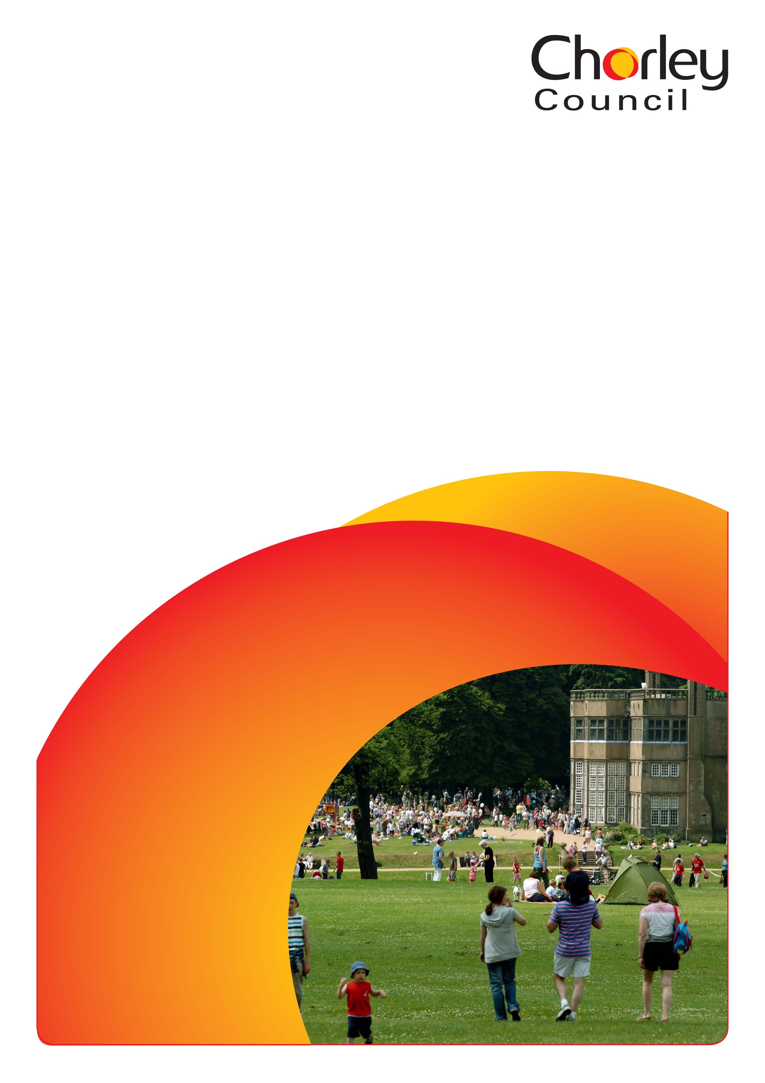

Event proposal form
For externally organised events on Chorley Council owned or managed sites
This form is for event organisers who wish to hold an event or activities in any Chorley Council managed parks, venues and open space sites. For the purpose of this form events can range from but are not exclusive to small community gatherings, sports races, charity walks, large multi-day carnivals and one day shows.

The council wishes to attract and develop a high quality events programme in the borough and this form allows organisers to put forward their event proposals to the land owner, Chorley Council. It will also seek to encourage organisers to make all of the considerations necessary to run a safe and legal event.

Your proposal will be processed by a council officer who is involved in the day-to-day management of the site or venue where you wish to hold your event.

We appreciate you may not have all of your event details confirmed but this is your chance to tell us as much information as possible at this stage to allow us to make a decision on whether your event can take place. Please follow the headings, as laid out and include all of the information requested and to the best of your knowledge.

Once fully completed, please send your proposal to events@chorley.gov.uk with Event proposal for [Insert name of location, site or venue] in the subject field or please post your proposal to Chorley Council using the following address: Event proposal for [Insert name of location, site or venue] Events Team, Chorley Council, Chorley Town Hall, Market Street, Chorley, PR7 1DP.

Section 1: Contact details

 | Name:
 | Address:
 | Email:
 | Telephone and mobile numbers: | Telephone:  Mobile:
 | Organisation or group:
 | Status: | Business/registered charity/ community group/ individual/ other (please state)
 | Have you any previous experience of organising events? If yes, please state.

Section 2: Your event

 | Title of event:
 | Dates of event: | From:  To:
 | Which venue would you like to use?
 | Describe your event giving as much detail as possible
 | Event opening hours | From:  To:
 | Set up and take down dates and times | Set up from/until:  Take down from/until:
 | Type of event | Community event for all/charity fundraising/private/ticketed/other (please state)
 | Is this a free event | Yes:  No:
 | Number of people you expect to attend?
j. | Number of participants including event staff, contractors, traders and performers?
k. | How many stewards are you providing?

Section 3: Attractions

 | Attractions | Yes? | No? | Names and contact details of operators
 | Funfair/children’s rides or equipment
 | Bouncy castles or other inflatables
 | Fireworks/pyrotechnics
 | Staging
 | Live music
 | Performing arts
 | Vehicles/motorcycles
 | Animals
 | Hot air balloon(s) or other air display
 | Commercial trade stands and charity stalls
 | Licensed bar
 | Catering outlets
 | Marquee(s)
 | Sports activity or games
 | Other (please state)

Section 4: Utilities

 | Does your event require electricity? | Yes: | No:
 | Will you be using generators for your event? | Yes: | No:
 | Does your event require a water supply? | Yes: | No:
 | Does your event require the use of public toilets? | Yes: | No:
 | Does your event require additional waste collection? | Yes: | No:

Section 5: Insurance and health and safety
 | Do you have public liability insurance cover for your event?  (Please note a minimum of £5 million public liability insurance is required for all events on council land and you will need to submit a copy of your certificate) | Yes:  No:
b. | Insurance company name and contact details
 | Policy number
 | Amount of cover
c. | Have you arranged first aid cover for your event? | Yes:  No:
d. | Name and contact details of first aid provider
 | How many first aiders will be at your event?

Section 6: Traffic and highway implications

If an event includes a street party, a parade, a procession, a carnival or other festival Chorley Council can temporarily close the roads using its powers under the Town and Police Clauses Act 1847. Some other types of events such as sporting events or large scale events may require a Temporary Traffic Regulation Order from Lancashire County Council under the Road Traffic Regulation Act 1984.

If Chorley Council is not able to issue a Road Closure Order under its statutory powers, it is the responsibility of the event organiser to ensure they have the necessary Temporary Traffic Regulation Order from Lancashire County Council and are able to provide a copy to Chorley Council on demand, for any events on the highway.

A road closure application will need to be made to the relevant council at least 16 weeks prior to the event.

 | Will you need to apply for a road closure?  (If yes, please contact Chorley councils legal services on 01257 515151) | Yes:  No:
b. | Please list the road or roads you wish to close for your event?
c. | Please provide details of parking arrangements for:  - Event staff, stewards, contractors, traders and other relevant staff  - Members of the public

Section 7: Event proposal information

Event proposal forms must be submitted in advance of the following deadlines:

Event size | Number of participants | Proposal deadline (before date of event)
Small event | 0-499 | 14 weeks
Medium event | 500-999 | 16 weeks
Large event | 1000-4999 | 6 months
Major event | 5000+ | 12 months

Once you have submitted your event proposal form you will be contacted by a Chorley Council officer no longer than three working days later to advise if your event proposal has provisionally been accepted.

You will then be expected to submit the following documents in order for a hire agreement to be issued:
- Event management plan
- Risk assessment
- Site map
- Traffic and parking management plan (if applicable)
- Public liability insurance

Event management and risk assessment templates are available for download on our website.

You will need to apply for any licences separately to this application by contacting Chorley Council’s licensing service on 01257 515151. View further information on licensing on our website.

You will need to apply for a road closure separately to this application by contacting Chorley Council’s legal services on 01257 515151 or emailing legal@chorley.gov.uk

Please bear in mind that although we are in contact with the emergency services it is the responsibility of the organisers to ensure that the emergency services are aware of the event and to arrange a presence, if necessary.

Following the submission of your event plans, they may be circulated to Chorley’s Event Safety Advisory Group for comment and you may be asked to attend a meeting to explain your plans further.

Approval for an event to go ahead on council land can only been given once all of the above plans and details have been submitted and a hire agreement has been signed. Please note all event organisers will also be expected to provide and receive an event review up to four weeks after the event has taken place.

