Chorley’s Clean Air Strategy
2021
(Updated May 2022)

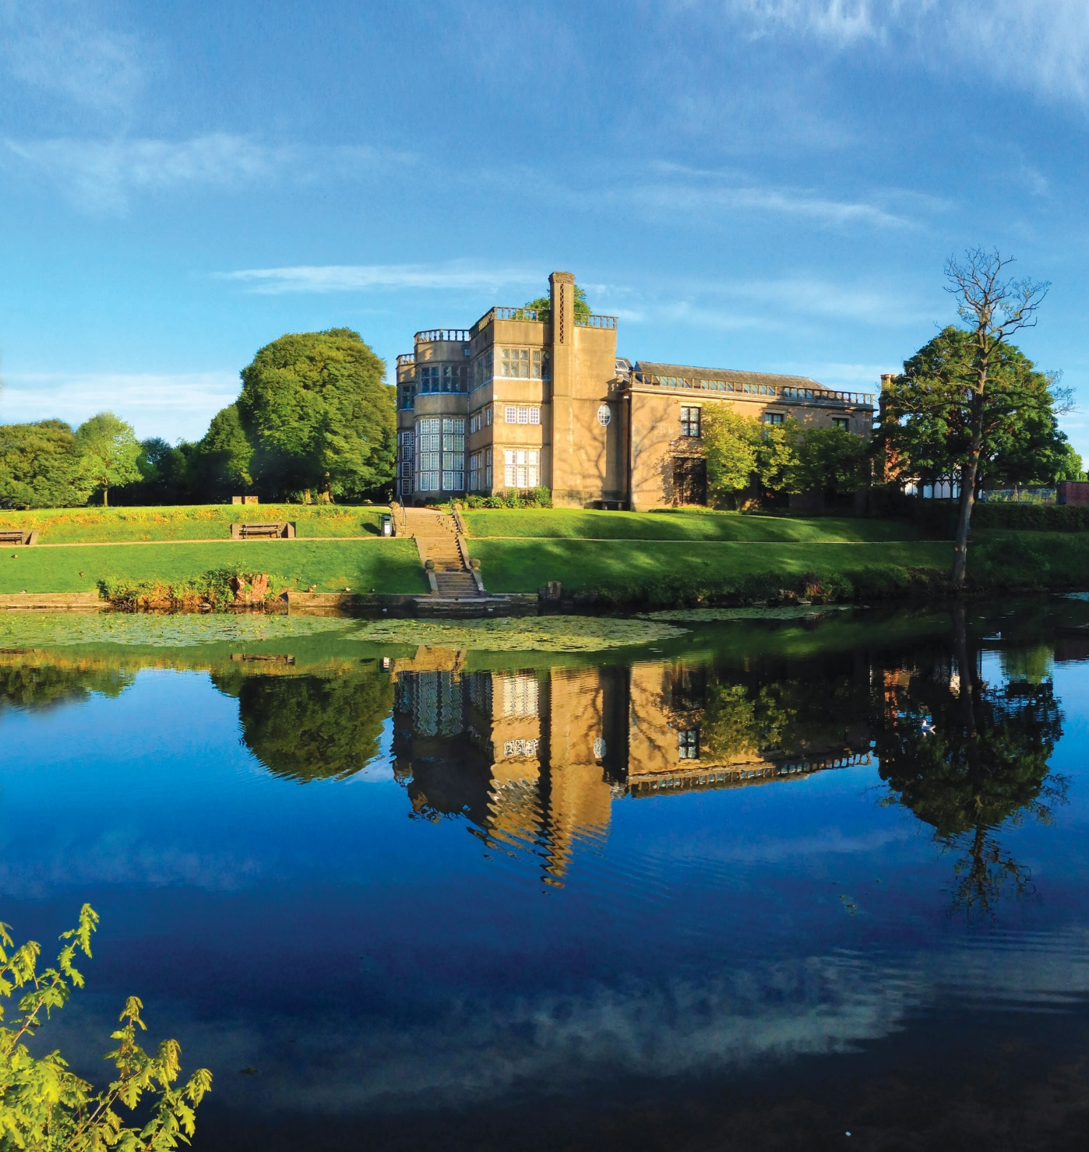

Executive Summary
The quality of the air we breathe plays a big part in the health of our local communities. It is our vision that people who live in, work in, and visit Chorley should be able to enjoy an environment which is clean and safe with air quality which is not harmful to their health.

The current legal limits on ambient air quality in Chorley are currently being met, however it is important that we fully understand the levels of pollutants across the Borough and ensure that the situation does not deteriorate.

The strategy set’s out Chorley Council’s aspirations for improving and maintaining healthy air quality across the Borough. The strategy is a living document and will be reviewed on a regular basis to enable updated actions to be included as technology and understanding improves

This document forms part of Chorley Council’s wider Green Agenda, which aims to improve the Borough’s environment and contributing to the Council’s evolving commitment to developing a strong and environmentally sustainable economy for future generations.
Improving and maintaining Air Quality is a priority for Chorley Council as it is an important factor in preserving and enhancing health and wellbeing and reducing harm to health.

We are delighted to endorse this strategy to improve air quality in Chorley, and the benefits it will deliver to the health of our residents’ and people who visit and work in our Borough.

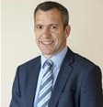
Councillor Alistair Bradley, Councillor Beverley Murray
(Executive Leader) (Executive Member Early Intervention)

Contents

Executive Summary 1
The Council’s Vision 3
Aims 3
Objectives 3
1. Introduction 1
2. What is Air Quality? 3
3. Statutory Requirements 5
Legal Requirements 5
National Policy and Guidance 5
4. Air Quality in Chorley Council 7
Chorley Council Area 7
5. Clean Air Strategy Consultation 9
Summary Consultation Findings 9
Consultation Conclusions 11
6. What the Council is currently doing regarding air quality improvements 12
Air Quality Monitoring 12
Reporting on Air quality 12
Planning and development 12
Climate Change 13
Greener vehicles 13
Reducing staff transport and encouraging active travel 13
Central Lancashire Local Plan 14
Partnership working with Public Health Lancashire 14
7. Proposed Actions 15
Potential barriers to implementing the Strategy’s actions 16
Appendix 1 – National Objective Values 17
Appendix 2 - Proposed Air Quality Actions 18
Appendix 3 - Clean Air Strategy Consultation Responses 24
Glossary 32

The Council’s Vision
The Council has a vision to act
“A proactive community leader, supporting the Borough and all its residents, whether in rural or urban areas, to reach their full potential through working in partnership to deliver services that achieve the best outcomes for local people and protect vulnerable people.”
Through this Clean air strategy, the Council has a vision that
“[…] all Chorley residents and visitors will have clean air that allows them to lead healthy and fulfilling lives.”
The Council will strive to understand the full extent of poor air quality across the Borough and identify the impacts this is having on out residents and visitors, particularly those who are vulnerable.
The strategy will identify actions and partner organisations who can assist in reducing the adverse impact of air pollution on the Borough.
Helping to achieve the Council’s overall vision and to protect and improve/maintain the lives of those who live and work within the Borough.

Aims
- To strive to maintain compliance with the national air quality standards.

- To reduce average concentrations of Nitrogen Oxides (NOx) and Particulate Matter across the Borough.

- To reduce the estimated proportion of disease and deaths attributed to air pollution.

Objectives
- To engage residents and businesses in the improvement of air quality initiatives.

- Enable the shift to zero and low emission transport to reduce emissions by providing the necessary infrastructure.

- Reduce, minimise, and prevent emissions from industrial, commercial, agricultural, and domestic sources and activities.

- Ensure all Council decisions have regard to the impact upon air quality.

Introduction
  - Air Quality is a priority for Chorley Council in addition to the Council’s legal responsibilities, ensuring good air quality is an important factor in maintaining and improving health and wellbeing and reducing harm to health.

  - The good news is that the monitoring and modelling data over the last few decades demonstrates that the air pollution levels in Chorley are below the current national air quality objectives. These are detailed in Appendix 1.

  - However, any level of air pollution can have a negative impact on the health and welfare of the population and there is always more that can be done to improve the quality of the air that we breathe.

  - Poor air quality contributes to both mortality and ill health in the population, with poor air quality leading to an estimated 36,000 premature deaths each year across the UK and accounting for 4.2% of all mortality in Chorley, the 4th highest in Lancashire.

  - In order to tackle poor air quality, the Council has committed a capital budget of £200,000 to both implement a more detailed monitoring programme of key air quality pollutants, across the Borough to help inform our future actions, and to progress many of the identified actions which will contribute to air quality improvements.

  - The Chorley Clean Air Strategy will help to identify the key areas for intervention, promote a partnership approach to air quality with health colleagues and provide a mechanism for engagement with key stakeholders. The strategy includes a list of actions to detail these areas, see Appendix 2.

  - The most important element of the strategy will be publicity and communications, to educate, inform and motivate the public to effect behavioural change, as this is the key to long term improvements in air quality. The development of a communications strategy will be a primary consideration and action for the Authority to support its endeavours to improve air quality.
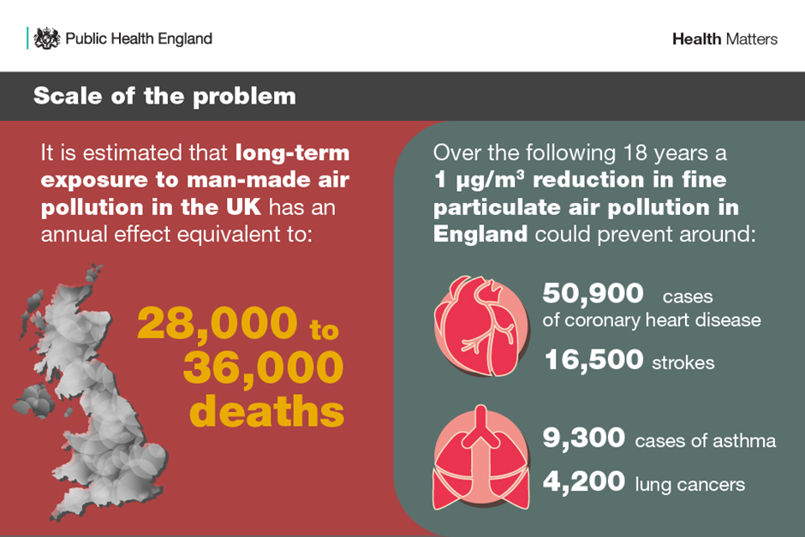Figure 1: Public Health England information campaign on the health effects of poor air quality.

What is Air Quality?

  - Air pollution can be defined as, “contaminant or pollutant substances in the air at a concentration that interferes with human health or welfare or produces other harmful environmental effects.”

  - Most outdoor air pollution in urban areas is man-made. Sources of air pollution chiefly comprise those involving combustion processes, such as:
    - Transport, particularly road traffic
    - Industrial and commercial sources
    - Domestic sources
    - Agricultural sources
    - Energy generation
    - Background and trans-boundary pollution (unavoidably brought into the area via weather systems).

  - Nine key pollutants have been identified which contribute towards poor air quality. These are:
    - Nitrogen Dioxide
    - Particulate Matter
    - Sulphur Dioxide
    - Carbon Monoxide
    - Benzene
    - 1,3-Butadiene
    - Lead
    - Ozone
    - Water Vapour

  - The principle pollutants of concern across the UK are currently Nitrogen Dioxide (NO₂) and Particulate Matter (PM₁₀ and PM_{2.5}).

  - Nitrogen Dioxide is produced as a by-product of burning fossil fuels, particularly from vehicle exhausts, but also from boilers and some industrial processes.

  - Particulate Matter is made up of solid and/or liquid materials of various sizes that range from a few nanometres in diameter (about the size of a virus) to around 100 micrometres (100 µm, about the thickness of a human hair).

  - The size of the particle is directly linked to the potential for causing health problems. Particles that are 10 micrometres in diameter or smaller generally pass through the throat and nose and enter the lungs. Once inhaled, these particles can affect the heart and lungs and cause serious health effects. These are known as PM₁₀ and concern is growing over the impact of even smaller particles PM_{2.5} (particles less than 2.5 micrometres).

  - Air pollution impacts everyone’s lives, increasing the risk of many diseases including cardiovascular disease, respiratory diseases like asthma and there is growing evidence that it can also increase the risk of dementia, low birth rates and diabetes.

  - There is often a strong correlation with equalities issues because areas with poor air quality are also often the less affluent areas with greater needs.

  - According to the Department for Environment, Food & Rural Affairs (DEFRA), poor air quality is the largest environmental risk to our health. There is increasing evidence that poor air quality is a significant contributor to preventable illnesses and early deaths. Whilst legal limits of air pollutant levels are in place, there is no ‘safe level’ and health effects can be seen below these limits. The 2017 annual report from the Chief Medical Officer clearly stresses that “addressing pollution is disease prevention.”
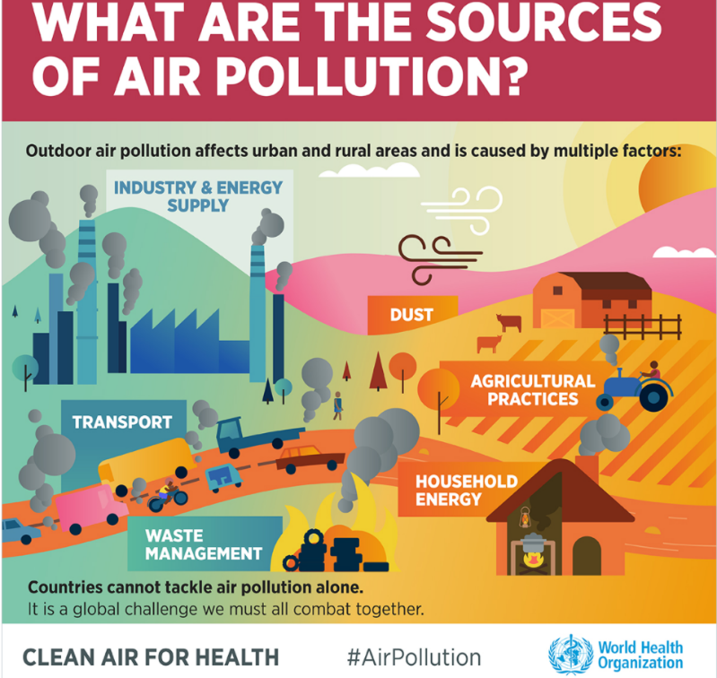
Figure 2: What are the sources of air pollution? Infographic from the World Health Organisation

Statutory Requirements

Legal Requirements
  - Section 82 of the Environment Act 1995 states that every local authority shall review the air quality within its area, both at the present time and the likely future air quality. In two-tier local government areas such as Chorley, this duty sits with the District and Borough Councils.

  - This review takes the form of an Annual Status Report (ASR), which is submitted to DEFRA each year. The most recent reports can be viewed on the Air Quality section of the Council's website.

  - Section 83 requires local authorities to designate an Air Quality Management Area (AQMA) where air quality objectives are not being achieved (or are not likely to be achieved) as set out in the Air Quality (England) Regulations 2000. Once designated, Section 84 requires the local authority to develop an Action Plan detailing remedial measures to tackle the problem within the AQMA.

  - At the time of writing Chorley does not currently have any AQMAs within the Borough. This is kept under constant review as part of the Annual Status Report.

  - There are also obligations placed on Lancashire County Council, detailed in the 2016 Defra Local Air Quality Management guidance. In summary, the district/borough councils are accountable for monitoring air quality, designating AQMAs, preparing the annual reports and Action Plans. However, the Secretary of State expects county councils to actively engage at all stages of review, assessment, and action planning, and ensure that all necessary measures to address air pollution in their local area are included.

National Policy and Guidance

  - The publication of the UK Government’s Clean Air Strategy sets out how the government will work to implement its 25-year environment plan, alongside its clean growth proposals. The cross-government plan is published jointly by the Department for Business, Energy and Industrial Strategy, Department for Environment, Food and Rural Affairs, Department for Transport, Department for the Health and Social Care, the Treasury, the Ministry of Housing, and the Department for Communities and Local Government. Chorley Council believe that this is a clear indication that poor air quality can only be tackled collaboratively across services, departments, and disciplines.

  - The UK Clean Air Strategy details a raft of new powers for local authorities and sets out a number of options which could be included in the Draft Environment (Principles and Governance) Bill 2018, although it is (at the time of writing) unclear who these duties would fall on within councils, nor how they would be funded. The Clean Air Strategy focusses on the importance of facilitating the sharing of best practice and knowledge between local authorities.

  - February 2019 saw the publication of the National Institute for Clinical Excellence (NICE) Quality Standard for outdoor air pollution and health, describing high-quality actions in priority areas for improvement. The standard is endorsed by The Department of Health and Social Care as required by the Health and Social Care Act (2012) builds on the 2017 publication of NICE air pollution guidance NG70.

  - Public Health England published a review of interventions to improve outdoor air quality and public health in March 2019, and was unequivocal in stating that the evidence for effective air quality interventions is developing all the time and can face challenges and limitations. This Strategy and Implementation Plan is mindful of this and recognises that ambition is of equal importance as setting out a public strategy that is achievable. The PHE review sets out several clear principles, which will further guide the development of the Implementation Plan, including:
- Local authorities need to work together
- Effective Strategies require a coherent approach
- Everyone has a role to play
- It is better to reduce air pollution at source than to mitigate the consequences
- Improving air quality can go hand in hand with economic growth
- As action is taken some groups may need tailored support

Air Quality in Chorley Council

Chorley Council Area
  - The Borough of Chorley lies in the Northwest of England at the heart of Lancashire. It covers an area of 78.3 square miles with a population of ~118,500.

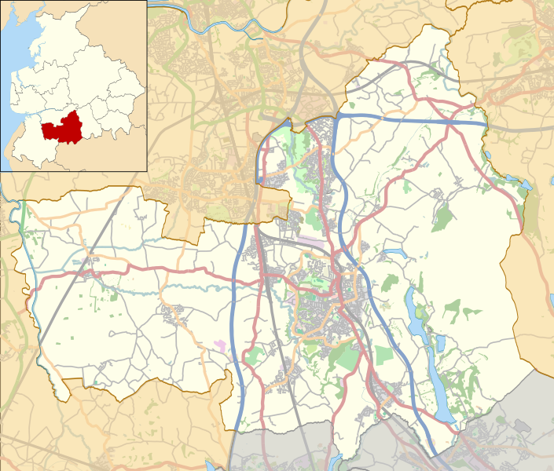
Figure 3: Map of Chorley Borough

  - The Borough has three busy motorways running through it, including parts of the M6, M61 and M65, along with several national trunk roads. Two railways, the West Coast mainline and the East Lancashire line, also run through the Borough.

  - Chorley Council currently monitors Nitrogen Dioxide emissions via a network of passive diffusion tubes location at strategic sites across the Borough, where there is a potential exposure to identified receptor groups. Locations of monitoring sites are published annually as part of our Annual Status Report.

  - During 2021 Nitrogen Dioxide sampling programme was revised and significantly expanded from 20 to 43 sampling locations.

  - Chorley Council has committed to enhancing the monitoring programme to utilise real-time particulate monitoring at strategic locations close to receptor groups.

  - The Council has recently invested in three EarthSense Zephyr continuous automatic particulate monitors. They are currently being trailed at three locations across the Borough to measure particulate pollution.

  - Once sufficient data has been collected, the results will be analysed to determine suitability and will allow some flexibility in siting them in other locations across the Borough. This will provide indicative data on particulate pollution trends and a benchmark against which to measure progress. The data will then be used to produce short, local campaigns around air quality.

  - Going forward we will be looking at the certification standards for low-cost particulate sensors as a whole, and their potential for inclusion in our formal air quality monitoring programme.

  - This extension of the monitoring programme will provide valuable information and insight into the wider pollutant levels across the Borough, allowing a greater understanding of the air quality across the area. This will allow a more targeted approach for future action to tackle poor air quality.

  - Current monitoring across the Borough has not identified any areas of concern above the national objective values, with a generally downward trend over the years at all monitoring locations.

  - Currently there are no Air Quality Management Areas declared within the Borough and Chorley Council has not been required to produce an Air Quality Action Plan.

  - To protect air quality and the health of residents, some areas of Chorley have been designated smoke control areas. As a result, there is a limit on how much smoke can be released from a chimney and only authorised fuels can be burned in an open fireplace or on an exempt appliance. More information and a map of these areas can be found on the Noise, nuisance and environmental complaints section of the Council's website.

Clean Air Strategy Consultation
  - To support the development of this Clean Air Strategy a public consultation exercise was run on Citizen Space from the 11th of June to the 16th of July 2021 and received 228 responses. The findings are summarised here, and the detailed responses are shown in Appendix 3.

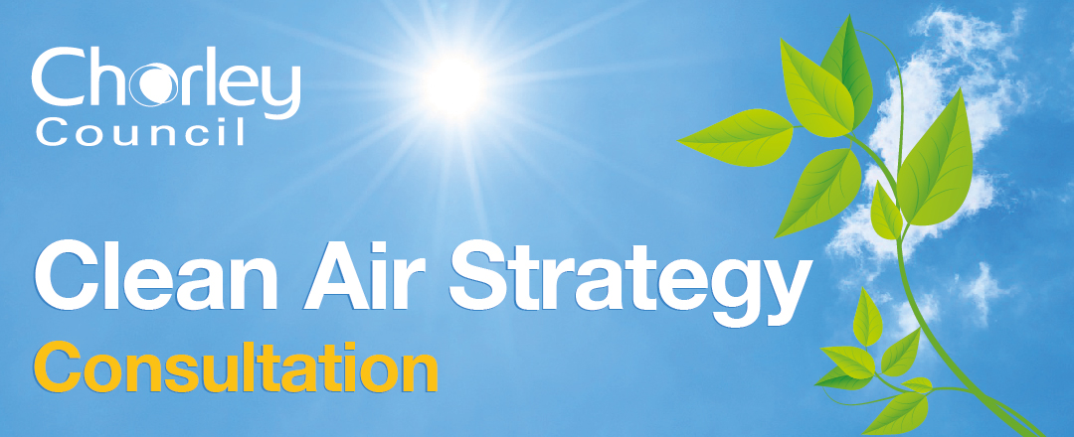
Figure 4: Clean air strategy banner

Summary Consultation Findings
  - Most respondents agreed air quality was either important or very important to them (92.5%). The top three reasons for this being health concerns, environmental reasons and issues relating to traffic.

  - All the proposed air quality objectives were well received, with each achieving over 85% support.

  - The greatest number of concerns raised by the survey were related to traffic and transport (including cycling and walking).

  - Over half of respondents told us that access to cycle routes and public transport links was important to them, rising to 85% for access to walking routes. 209 of the 224 respondents want to see improvements in the quality of walking and cycling routes.

  - With regards to electric vehicles, 70% of people would like greater access to charging points.

  - The second most important point raised related to burning and smoke. This is an area of work we will develop further through a combination of awareness raising and, where necessary, enforcement activities.

  - The third issue raised was engagement with industry and business on air quality matters. This was explored in further detail during the consultation. The proposed opportunities residents would like to see implemented by industry were given equal importance and a high level of support (67.5-78.5%). These were:
- Increased monitoring/awareness of emissions
- Alternative transport such as lower emission or electric vehicles
- Improving heating systems e.g. limiting fuel burning
- Using supply chain companies which also limit air pollution
- Implement improving air quality into business policy and strategies

  - 73% of people would choose to visit a business taking positive steps to improve air quality. Rising to 76% of people who would choose to use a taxi company that runs lower emission vehicles.

  - To implement these measures businesses told us that they require access to funding as well as access to awareness campaigns and training events.

  - On the general engagement side it was felt that more could be done to inform residents on how the Council carries out air quality monitoring, with a similar number of people saying that it an important thing to do to inform decisions and understand the impact on health.

  - Several people made comments relating to the number and location of air quality monitoring sites. During a review in 2021, the Council has since doubled the number of NOx diffusion tube monitoring locations, as well as started a trial of continuous air monitors which have the potential to give real-time data on particulate matter levels.

  - The final consultation question was about what Chorley Council should be doing to tackle climate change. 155 people left comments for this section.

  - The Air Quality specific comments covered topics including better enforcement of the air quality legislation, traffic concerns and allowing people access to our data.

Consultation Conclusions
  - In response to concerns about traffic and active travel infrastructure Chorley Council is keen to work with Lancashire County Council, the body responsible for Highways, to look at ways we can make improvements in this area to the benefit of our residents and visitors.

  - Other areas noted in the initial version of the action plan (e.g. electric vehicles) received a large amount of public interest and it was important to consider these properly. Therefore, following the consultation it was decided that these areas would be better to separate out and explore further in the Climate Change strategy.

  - Some of the comments raised during the consultation were not strictly air quality related. However, where possible they have been considered and taken forward to inform the creation of the Climate Change strategy.

  - Following analysis of the consultation responses it is agreed that more engagement could be done by the Council to promote our air quality work and the publication of data, to keep residents informed using a variety of media to reach all members of society.

  - This will include making better use of the Council website with accompanying awareness raising when the air quality Annual Status Reports are published.

  - The Air Quality Actions have been updated following on from the concerns raised by residents and to make our messaging more relevant.

What the Council is currently doing regarding air quality improvements

Air Quality Monitoring
  - A strong evidence base is essential to understand the air quality within the Borough, not only to identify areas of concern but to assist in developing actions for improvement and ensuring areas do not deteriorate.

  - The Council currently monitors Nitrogen Dioxide emissions from traffic sources using Passive Diffusion Tubes across the Borough, which provide data on the level of Nitrogen Dioxide emissions.

  - As mentioned in section 4, the monitoring programme is under constant review and some of the £200,000 funding has been utilised to make improvements and purchase continuous particulate monitors for use in areas of greatest concern to establish a more detailed evidence base.

Reporting on Air quality
  - Chorley Council produce an Annual Status Report (ASR) which is submitted to DEFRA for approval and published on the Council’s website, in-line with statutory requirements. This report provides an annual update on air pollution monitoring results and trends, updating on the progress of measures being implemented across the Borough to improve air quality, not just by Chorley Council, but partners and outside agencies.

Planning and development
  - Chorley Council requests air quality assessments for planning applications where the development may impact on air quality or where the development is close to an existing source of air pollution. The assessments are required to identify if there are any potential impacts on air quality resulting for development in that location. It is recognised that the standard methodology used across the country is not currently fit for purpose and does little to prevent a gradual decrease in air quality.

  - A Lancashire wide draft policy document on how air quality impacts should be considered by developers has been produced. This policy will address some of the issues in the current modelling system.

Climate Change

  - Since the initial draft of the Air Quality Strategy, Chorley Council has launched a separate Climate Change strategy to reaffirm our commitment to the Climate Emergency which was declared in November 2019.

  - There is some crossover between the Air Quality Strategy and the Climate Change strategy as well as other corporate priorities. Therefore, for consistency and accountability some actions referred to below have been reviewed and incorporated elsewhere. Where this is the case, please follow the signposts to the relevant document.

Greener vehicles
  - Chorley Council introduced a Taxi policy in 2017 to require the updating of the fleet to less-polluting vehicles by 2021. This is not a static policy and we will continue to demand better performing and greener vehicles from the trade as new technology emerges.

  - In addition, Chorley Council have introduced greener vehicles within their own fleet to reduce exhaust emissions, with a range of electric vehicles and the installation of charging points at the depot. (Incorporated into Climate Change Strategy 2022 Priority Two: Deliver the decarbonisation of Council owned assets and improve the sustainability of the Councils fleet)

Reducing staff transport and encouraging active travel

  - Chorley Council and South Ribble Borough Council have opened an account with Northern rail to offer staff the opportunity to spread the cost of an annual rail season ticket over 12 months. The annual rail season ticket is charged at a regulated fare. The advantage to Chorley Council employees is to spread the cost of the season ticket over 12 months, through monthly salary deductions.

  - Chorley Council offer participation in a cycle to work scheme, allowing staff to spread the cost of a bicycle over 12 months.

Central Lancashire Local Plan
  - A key action for Chorley Council and the neighbouring local authorities of South Ribble Borough Council and Preston City Council is the revision and updating of the Central Lancashire Local Plan. This plan is being prepared in partnership with all 3 Councils and Lancashire County Council are also involved through their role in updating the Central Lancashire Transport Masterplan.

  - The production of the new Central Lancashire Local Plan is an immensely important factor in shaping our communities for the future and ensuring sustainable development.

  - Officers from all three authorities have been providing input and expertise in relation to air quality, with a particular focus on sustainable development, energy generation and conservation, alternative transport options and the infrastructure inclusions necessary to encourage behavioural change while still delivering economic growth.

  - This ambitious plan will then support the individual authorities to implement planning guidance that seeks to minimise any negative impact of development on air quality and strive to improve air quality.
(Incorporated into Climate Change Strategy 2022 Priority Three: Develop robust planning policies to deliver adaption and mitigation and Priority Four Provide safe spaces for walking and cycling, promote sustainable public transport and greener private and commercial vehicles.)

Partnership working with Public Health Lancashire
  - Chorley Council works closely with Public Health colleagues at Lancashire County Council. Working with district councils, Lancashire County Council has an important role to play in taking action to reduce these health impacts of air pollution. Responsible for education, transport planning, network management, highway maintenance, public health and procuring local vehicle fleets, there are many ways Lancashire County Council supports local and county wide efforts to improve air quality.

Proposed Actions
  - The actions identified by this strategy fall within several distinct themes and can also be categorised as meeting short, medium, and long-term delivery goals. In the interests of working with partner Council’s within Central Lancashire these themes have been identified are in line with those used within our neighbouring authority of South Ribble, with whom Chorley Council already have several shared services and a shared management team.

  - The identified themes are:
    - Planning Development
    - Infrastructure & Transport
    - Internal Actions to address Air Quality
    - Engagement

  - This strategy is a living document and therefore the key identified actions will continue to be monitored and evolve as we progress, and technological and scientific understanding and development occurs.

  - The identified actions are included within the table in Appendix 2.

  - The strategy and air quality actions will be reviewed every 12 months to update it with the progress made to the identified actions and to detail any improvements or changes identified.

  - Following this update some actions were found to fit better within the new Climate Change Strategy. Where this is the case, please follow the signposts to the relevant document.

  - The actions proposed are ambitious but realistic, although they will depend on a commitment of resources and funding to ensure delivery to meet our overriding vision of improving air quality within Chorley.

  - One of the key actions is to develop a communications and engagement strategy. Alongside policy changes, improved monitoring and working with partners to develop infrastructure and access to green technologies, behavioural change is fundamental. This modal shift by society to embrace active travel and alternatives to our current transport use and energy generation requires a commitment from individuals as well as support for sustainable infrastructure. But the benefits are significant.

Potential barriers to implementing the Strategy’s actions
  - There may be several barriers and difficulties to overcome to meet our goal:
- Apathy from the public needs to be addressed by providing more information and engaging with different groups of people to encourage behavioural change. There is a need to develop a sophisticated communications strategy alongside and in support of Chorley’s Clean Air Strategy.
- Inaccurate data, resulting in unclear or alarmist messages that may ultimately detract from the overall aims of the strategy. Data and communications need to be properly managed.
- Financial constraints that restrict our ability to implement change or gather accurate data and evidence to support our proposals. Identify funding options and research the most cost effective but appropriate tools to support our strategy. The Council has committed £200,000 towards the air quality agenda.
- The fear that sustainable development policies will have a negative impact on the local economy, discouraging investment in Chorley.
- Diversion of staff, particularly in partner organisations, away from wider public health work (including air quality) to deal with the pandemic.
- The necessary steps required to implement new policy to ensure compliance with the democratic and legal process may be barrier to expedient delivery of some actions.

Appendix 1 – National Objective Values
Pollutant | Air Quality Objective: Concentration | Air Quality Objective: Measured as
Nitrogen Dioxide (NO₂) | 200µg/m³ not to be exceeded more than 18 times a year | 1-hour mean
Nitrogen Dioxide (NO₂) | 40µg/m³ | Annual mean
Particulate Matter (PM₁₀) | 50µg/m³, not to be exceeded more than 35 times a year | 24-hour mean
Particulate Matter (PM₁₀) | 40µg/m³ | Annual mean
Sulphur Dioxide (SO₂) | 350µg/m³, not to be exceeded more than 24 times a year | 1-hour mean
Sulphur Dioxide (SO₂) | 125µg/m³, not to be exceeded more than 3 times a year | 24-hour mean
Sulphur Dioxide (SO₂) | 266µg/m³, not to be exceeded more than 35 times a year | 15-minute mean
The units are in micrograms of pollutant per cubic metre of air (µg/m³).

Appendix 2 - Proposed Air Quality Actions

The actions identified by this strategy fall within four distinct themes and we will also identify which actions will fall within short (0-12 months), medium (12-36 months) and long (+36 Months) term delivery goals.

Those four themes are:
- To engage residents and businesses in the improvement of air quality initiatives
- Enable the shift to zero and low emission transport to reduce emissions by providing the necessary infrastructure
- Reduce, minimise, and prevent emissions from industrial, commercial, agricultural, and domestic sources and activities
- Ensure all Council decisions have regard to the impact upon air quality

Table 1: Chorley Clean Air Strategy Action Plan
No | Objective | Description | Lead Officer /Team | Senior Officer | Start Date | Target Date | Comments/  Progress | Completion Date
1 | Develop an engagement strategy to support the AQ agenda across the Borough | Develop a communications and engagement strategy to raise awareness of air quality across the Borough and to help achieve identified actions under the strategy. | Public Protection/  Comms/ Spatial Planning | Laura-Jean Taylor | Jan 21 | Jul 21  On-going with  annual review | Changed to continuous programme with review. Covid-19 messaging was priority during 2021.  2022 - soft-launch of “Ready to Burn” social media campaign - will link with wider PM campaign and Clean Air Day in June. | On-going
1 |  | Launch strategy consultation to engage residents and identify concerns | Public Protection/  Comms | Laura-Jean Taylor | Jan 21 | Jul 21 | 228 responses received and reviewed to inform strategy updates. | Complete  Jul 21
1 |  | Identify calendar of opportunities to link with AQ engagement. | Public Protection/ Comms | Laura-Jean Taylor | Jan 22 | Aug 21 | Draft produced linked to seasonal activities, e.g. ASR publication, “Clean Air Day” and “Ready to Burn” in colder months | On-going
1 |  | Work with local partners and neighbouring authorities to carry out larger outreach and information activities on AQ. | Public Protection/  Comms | Laura-Jean Taylor | Jan 22 | Dec 22 | New Air Quality officer joined to take forward. Developing activities with SRBC. | On-going
1 |  | Develop training or webinars aimed at businesses in Chorley on Air Quality. | Public Protection/  Comms | Laura-Jean Taylor | Jan 22 | Jul 23 | New Air Quality officer joined to take forward. Establishing suitable programme | On-going
2 | Review Taxi Policy | Investigate changes to the current policy to incentivise the uptake of low and zero emission vehicles | Enforcement Team | Asim Khan/ Nathan Howson | Dec 20 | Dec 21 | The current Chorley Taxi Policy is due to be reviewed in 2020. Lancashire EPG – air quality group have a template for introduction across Lancashire, backed by PHL. | No Update Available
2 | Active Travel & Cycling project | Establish a plan to look at opportunities, and cycle routes in the Borough. Identify areas of responsibility with LCC. | Spatial Planning | Zoe Whiteside | Jun 22 | Dec 22 | Engagement plan developed to identify work areas and enable alternative travel options e.g., cycling, walking, and wheeling across the Borough. | On-going
3 | Ensure all new development contributes to delivering Clean Air Strategy | Publish the draft Lancashire Air Quality Low Emission developer guidance document air quality. Start to role this out now and embed the guidance as part of the review of the Local Plan. | Service Lead Planning Services /  Public Protection | Shared Director of Planning and Development |  | Dec 2021 | Revise draft Lancashire guidance for Chorley and start to implement now. Embed the guidance with Local Plan, which is currently being developed. | On-going
3 |  | Review EPR permit licensing scheme and enforcement for businesses | Public Protection/ Comms | Laura-Jean Taylor | Jan 21 | Dec 22 | New Air Quality officer in post to take forward | On-going
3 |  | Respond to UK government consultations on air quality relating to planning and construction | Service Lead Planning Services /  Public Protection | Shared Director of Planning and Development |  | On-going | Respond as and when UK Government asks for input | On-going
4 | Review the Air Quality Monitoring programme across the Borough. | Revise and increase the level of air quality monitoring across the Borough. Investigate the potential for a continuous analyser for PM. | Team Leader Public Protection | Shared Director of Communities | Apr 21 | Ongoing | Increased locations of passive monitoring diffusion tubes and acquired particulate automatic monitors. Locations to be reviewed once sufficient data has been collected. | Complete  Dec 21
4 |  | Review results from continuous PM analyser trial and assess suitability of location. | Public Protection | Laura-Jean Taylor | Jul 22 | Dec 22 | Requires results from 2022 Annual Status Report before starting. | Not started
4 | All council decisions include an assessment of Air Quality impacts | Council report templates to require an assessment of the impact of any proposal on Air Quality in the Borough. | Service Lead Democratic Services | Director of Governance | Dec 2020 | Jan 2021 | ‘Climate change and air quality’ section added to templates. | Complete Jan 2021
4 | Promote flexible and homeworking to reduce commuting and avoidable travel | Review working from home policy | HR Manager | Service Lead for Transformation and Partnerships | Apr 21 | Sept 21 | Adopted a hybrid-working charter, incorporated into business plan by service leads. | Complete March 2022

Table 2: Previous action points transferred to climate change strategy
Objective | Description | Lead Officer /Team | Senior Officer | Start Date | Target Date | Comments/Progress
Work with County on the review and update on the Lancashire Local Transport Plan and Central Local Plan team on measures to be introduced locally on transport options | Liaise with Policy makers on development of transport policy at both County and Local Plan level. Ensure policies support move to sustainable and active travel and a move away from reliance of road transport. This will also need to include review of road layout and traffic light sequencing to improve traffic flows. | LCC Transport planners/ Central Lancs Local Plan Team | Chris Sinnott | Dec 20 | Dec 23 | Ongoing process through the Local Plan and wider engagement on County Transport planning and the Central Lancashire Transport Masterplan
Promote Active Travel for staff | Look at staff policies to encourage active travel to work and support this through the provision of secure bike storage and changing/shower facilities for staff as part of the building improvement and maintenance programme | Property Services/  Human Resources | Hollie Walmsley/ David Taylor | Apr 21 | Sept 21 | Changes may have implications for staff working arrangements and CLT need to be involved in any discussions on this.  Moved to Climate Change Strategy
Promote Active Travel across the Borough | Develop strategies and promote movement away from the reliance on the car as a primary mode of transport | Spatial Planning | Zoe Whiteside | Jan 21 | Dec 22 | Need to consider improvements required on cycle networks and increased safety on PRoW  Moved to Climate Change Strategy
Increase the provision of EV Charging Points across the Borough | Investigate the potential locations for on and off street EV charging | Spatial Planning | Zoe Whiteside | Apr 21 | Sept 21 | EV chargers have begun to be installed on council car parks  Moved to Climate Change Strategy
Improved access to Electric vehicles Charging options | Review car park charging policy relating to EV’s and consult with public on measures to incentivise alternative travel  Look at ways to provide better access to EV on and off-street parking | Commercial Services | Mark Lester/ Shared Director (Commercial) | Apr 21 | Oct 21 | EV chargers have begun to be installed on council car parks  Moved to Climate Change Strategy
Electric Vehicles Charging Points | Source funding to implement additional installation. | Spatial Planning | Zoe Whiteside | Jun 21 | On-going | Moved to Climate Change Strategy

Appendix 3 - Clean Air Strategy Consultation Responses
The consultation ran online using Citizen Space from 11/06/2021 to 16/07/2021.
Responses to the survey: 228

1: On a scale of 1- 5 (with 5 being very important) please rank below how important clean air quality is to you.
Importance of air quality - ranking
There were 228 responses to this part of the question.
Option | Total | Percent
1 | 4 | 1.75%
2 | 2 | 0.88%
3 | 11 | 4.82%
4 | 26 | 11.40%
5 | 185 | 81.14%
Not Answered | 0 | 0.00%

2: Please let us know the reason for your ranking in the box below:
Reasons for ranking the importance of Clean Air Quality
There were 215 responses to this part of the question.
Number of responses relating to concerns in themes, some people mentioned more than one:
Health Concerns: 97
Road Traffic (fumes, sitting in idle, motorways & main roads): 16
Environmental reasons: 21
Use of gas boilers: 1
Dust: 1
Industrial actions: 4
Lack or destroying of green spaces/trees: 4
Awareness since Covid: 4
Use of wood burners: 2

3: Below are our main proposed objectives for the Clean Air Strategy – please score how important they are to you (with 5 being very important).
Ranking of Clean Air Strategy Objectives – To engage residents and businesses in the improvement of air quality initiatives
There were 228 responses to this part of the question.
Option | Total | Percent
1 | 7 | 3.07%
2 | 4 | 1.75%
3 | 22 | 9.65%
4 | 53 | 23.25%
5 | 142 | 62.28%
Not Answered | 0 | 0.00%

Ranking of Clean Air Strategy Objectives – Enable the shift to zero and low emission transport to reduce emissions by providing the necessary infrastructure
There were 228 responses to this part of the question.
Option | Total | Percent
1 | 10 | 4.39%
2 | 7 | 3.07%
3 | 17 | 7.46%
4 | 37 | 16.23%
5 | 157 | 68.86%
Not Answered | 0 | 0.00%

Ranking of Clean Air Strategy Objectives – Reduce, 4inimize and prevent emissions from industrial, commercial, agricultural, and domestic sources and activities
There were 228 responses to this part of the question.
Option | Total | Percent
1 | 6 | 2.63%
2 | 4 | 1.75%
3 | 21 | 9.21%
4 | 46 | 20.18%
5 | 151 | 66.23%
Not Answered | 0 | 0.00%

Ranking of Clean Air Strategy Objectives – Ensure all Council decisions have regard to the impact upon air quality
There were 228 responses to this part of the question.

Option | Total | Percent
1 | 6 | 2.63%
2 | 10 | 4.39%
3 | 18 | 7.89%
4 | 38 | 16.67%
5 | 156 | 68.42%
Not Answered | 0 | 0.00%

4: If you would like to provide further comments, please do so in the box below
Reasons for ranking Clean Air Strategy Objectives
There were 91 responses to this part of the question.
Number of responses relating to additional concerns in themes, some people mentioned more than one:
Agreeing with objectives: 4
Ban/regulate use of wood burners: 8
Government more influential than council: 1
Tax, policy, and concerns surrounding use of petrol and diesel cars: 28 (+ 2 did not want EV cars on road either)
More resources: 1
Sustainable initiatives: 2
Smoke Control areas: 1
Behaviour changes: 1
Changing policy and laws: 2
Increase green space work: 7
Industrial (monitor, influence, tax): 7
Takeaways and fat burning: 2
Improve cycle and walking ways: 19
Indoor monitoring: 2
Follow WHO guidance: 1
Food waste recycling: 1
Landfill gases: 1
Fires: 1

5: What action/contributions towards air quality would you like to see from businesses in the Borough? Please select all those that apply.
Actions residents would like to see from businesses
There were 228 responses to this part of the question.
Option | Total | Percent
Increased monitoring/awareness of emissions | 179 | 78.51%
Alternative transport such as lower emission or electric vehicles | 178 | 78.07%
Improving heating systems e.g. limiting fuel burning | 158 | 69.30%
Using supply chain companies which also limit air pollution | 154 | 67.54%
Implement improving air quality into business policy and strategies | 157 | 68.86%
Other | 31 | 13.60%
Not Answered | 0 | 0.00%

6: If you selected 'other' please state in the box below:
If you selected 'other' (to what actions you would like to see from businesses in the Borough) please state below:
There were 39 responses to this part of the question.
Improve encourage public transport: 4
Use local suppliers: 2
EV taxi’s and EV business fleets: 3
School traffic concerns: 1
Zero emission businesses (council promote or advise): 6
Stoop burning wood, oil, and coal: 5
Plant trees: 4
Lower uniform waste: 1
No idle policy: 1
Green buildings: 4
Reporting to council: 3
Tax breaks: 2
Recycling: 1
Indoor AQ monitoring: 1
Turn off lights: 1

7: If you are a business owner, what support would you like to see implemented to help businesses contribute to clear air?
Support businesses would like to help contribute to clean air
There were 57 responses to this part of the question.
Option | Total | Percent
Access to funding | 41 | 17.98%
Access to awareness campaigns/information | 38 | 16.67%
Webinars | 17 | 7.46%
Other | 6 | 2.63%
Not Answered | 171 | 75.00%

8: If you selected 'other', please state in the box below:
If selected 'other' support you would like to see for businesses, please state in the box below:
There were 10 responses to this part of the question.

9: In terms of local transport what is most important to you? Please score below (with 5 being very important).
Importance ranking for local transport - Access to cycle routes
There were 228 responses to this part of the question.
Option | Total | Percent
1 | 41 | 17.98%
2 | 23 | 10.09%
3 | 40 | 17.54%
4 | 39 | 17.11%
5 | 85 | 37.28%
Not Answered | 0 | 0.00%

Importance ranking for local transport - Access to public transport links
There were 228 responses to this part of the question.
Option | Total | Percent
1 | 15 | 6.58%
2 | 18 | 7.89%
3 | 40 | 17.54%
4 | 56 | 24.56%
5 | 99 | 43.42%
Not Answered | 0 | 0.00%

Importance ranking for local transport - Access to electric vehicle charging points
There were 228 responses to this part of the question.
Option | Total | Percent
1 | 33 | 14.47%
2 | 15 | 6.58%
3 | 54 | 23.68%
4 | 39 | 17.11%
5 | 87 | 38.16%
Not Answered | 0 | 0.00%

Importance ranking for local transport - Access to walking routes
There were 228 responses to this part of the question.
Option | Total | Percent
1 | 10 | 4.39%
2 | 8 | 3.51%
3 | 14 | 6.14%
4 | 40 | 17.54%
5 | 156 | 68.42%
Not Answered | 0 | 0.00%

Importance ranking for local transport - Quality of footpaths and cycle paths
There were 228 responses to this part of the question.
Option | Total | Percent
1 | 7 | 3.07%
2 | 4 | 1.75%
3 | 8 | 3.51%
4 | 26 | 11.40%
5 | 183 | 80.26%
Not Answered | 0 | 0.00%

10: How important do you think an increase in electric vehicle charging points in the Borough is? Please rank below (with 5 being most important).
Ranking of how important an increase in EV Charging points is
There were 228 responses to this part of the question.

Option | Total | Percent
1 | 15 | 6.58%
2 | 13 | 5.70%
3 | 39 | 17.11%
4 | 54 | 23.68%
5 | 107 | 46.93%
Not Answered | 0 | 0.00%

11: Would you be more likely to use a business that has considered/implemented measures towards clean air?
Using businesses that have implemented clean air measures
There were 228 responses to this part of the question.
Option | Total | Percent
Yes | 167 | 73.25%
No | 3 | 1.32%
This wouldn't influence my decision | 58 | 25.44%
Not Answered | 0 | 0.00%

12: If given a choice, would you be more likely to be use a taxi company that runs lower or zero emission vehicles?
Use of taxi companies that run lower emission vehicles
There were 228 responses to this part of the question.
Option | Total | Percent
Yes | 174 | 76.32%
No | 1 | 0.44%
This wouldn't influence my decision at all | 53 | 23.25%
Not Answered | 0 | 0.00%

13: Are you aware of the council’s current air quality monitoring methods?
Awareness of council’s air quality monitoring methods
There were 228 responses to this part of the question.
Option | Total | Percent
Yes | 29 | 12.72%
No | 199 | 87.28%
Not Answered | 0 | 0.00%

14: Do you think it is important to monitor air quality/particles?
Importance of monitoring air quality/particles
There were 228 responses to this part of the question.

Option | Total | Percent
Yes | 201 | 88.16%
No | 3 | 1.32%
Don't feel strongly either way | 24 | 10.53%
Not Answered | 0 | 0.00%

15: If answered yes, please explain further in the box provided below
Explain why you feel it is important to monitor air quality/particles
There were 150 responses to this part of the question.
Health reasons: 41
Knowledge and informed decisions: 73
For funding purposes: 2
Locate it near schools: 2
Add more locations: 7
Real time monitoring near foot paths: 1
To show traffic concerns: 10
Monitor near businesses: 2
Publish Data: 6
Concerns of AQ in town Belden: 1
Wood burner concerns: 3
Public transport (use of it, more of it and stop idle): 2
Dust concerns: 1
Monitor for planning applications: 1
Need for trees: 1

16: How are you most likely to find out about our work on the Clean Air Strategy or other climate emergency related initiatives:
How are you most likely to find out about climate emergency related initiatives
There were 228 responses to this part of the question.
Option | Total | Percent
Council website | 89 | 39.04%
Council social media pages | 150 | 65.79%
Emails from the council | 75 | 32.89%
Local newspapers | 55 | 24.12%
Community groups | 37 | 16.23%
Environmental groups/organisations | 68 | 29.82%
Through schools | 47 | 20.61%
Other | 20 | 8.77%
Not Answered | 0 | 0.00%

17: If you selected 'Other' please state in the box below
If answered 'other' please state in box below
There were 20 responses to this part of the question.

18: What else would you like to see us do when it comes to tackling climate change?
What else would you like to see us do?
There were 155 responses to this part of the question.
Improve green spaces, plant more trees: 32
Fines for polluting: 2
Walk/cycle/public transport improvements: 19
Green energy for the council, for new buildings and for businesses: 19
Stop cars being in idle: 12
Stop wood burners: 12
Green businesses (promote, encourage): 6
EV for council fleet, more charge points, have them in new buildings: 19
Taxation on cars and businesses: 5
Recycling (more of it, explain best practice, food recycling): 14
Incentives for businesses and residents: 2
Stop building houses: 17
Greater power for Chorley Council: 2
Traffic concerns: 9
Online advise: 4
Publish data: 3
Promoting vegan lifestyle: 1

Glossary

Abbreviations | Description
AQAP | Air Quality Action Plan – a detailed description of measures, outcomes, achievement dates showing how the local authority intends to achieve air quality limits.
AQMA | Air Quality Management Area – An area where air pollutant concentrations exceed / are likely to exceed the relevant air quality objectives. AQMAs are declared for specific pollutants and objectives.
ASR | Annual Status Report
DEFRA | Department for Environment, Food and Rural Affairs
EU | European Union
LAQM | Local Air Quality Management
LCC | Lancashire County Council
NO₂ | Nitrogen Dioxide
NO_{x} | Nitrogen Oxides
PM10 | Airborne particulate matter with an aerodynamic diameter of 10 µm or less
PM_{2.5} | Airborne particulate matter with an aerodynamic diameter of 2.5 µm or less

https://fingertips.phe.org.uk/indicator-list/view/uWvxADQhNU#page/0/gid/1/pat/302/par/E10000017/ati/301/are/E07000118/iid/30101/age/230/sex/4/cid/4/tbm/1/page-options/ovw-do-0
air pollution — European Environment Agency (europa.eu)
Chief Medical Officer annual report 2017: health impacts of all pollution - GOV.UK (www.gov.uk)
https://laqm.defra.gov.uk/documents/LAQM-PG16-April-16-v1.pdf
https://www.gov.uk/government/publications/clean-air-strategy-2019
https://www.nice.org.uk/guidance/ng70
https://assets.publishing.service.gov.uk/government/uploads/system/uploads/attachment_data/file/784055/Review_of_interventions_to_improve_air_quality.pdf

